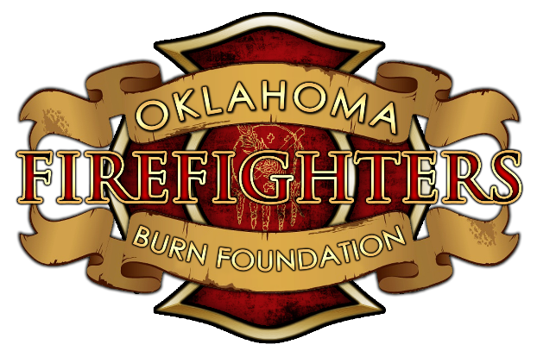
The Fitzpatrick Scholarship
&
The Yates Scholarship
The Fitzpatrick Scholarship was established in 2011 to honor the life of Justin Fitzpatrick. The Yates Scholarship was established in this year 2019, this scholarship is to honor the life of KJ Yates. Both Justin and KJ have been representative of the spirit of Burn Camp. The memory of Justin continues to be honored through this scholarship for a full time student, and the memory of KJ through the part time scholarship.
In order to be a candidate of the Fitzpatrick or Yates Scholarship he/she must have been previously enrolled as a camper at the Oklahoma Firefighters Burn Camp. In addition, candidates must prove continued involvement as a counselor or volunteer to individuals with disfiguring injuries and/or burns.

Candidates must fill out the scholarship application attached with the following materials no later than June 30th, 2019.
- Official high school transcript and any college transcripts (if applicable)
- A reference letter must be submitted addressing the following question (this reference must be someone other than family or camp staff:
  - Why does the applicant deserve or need such scholarship?
- A reference letter submitted from any camp staff member addressing the following question:
  - In your experience with this applicant, how have they shown that they represent the spirit of Burn Camp?
Requirements for the full scholarship:
- Candidates must have applied and been accepted to take at least 12 credit hours at an accredited institution of the following:
  - Two year college (Junior College)
  - Four year college (University)
  - Trade/Vocational school
Requirements for a partial scholarship:
- Candidates must have applied and been accepted to take at least 6 credit hours at an accredited institution of the following:
  - Two year college (Junior College)
  - Four year college (University)
  - Trade/Vocational school
Applicants for a full or partial scholarship must currently carry a GPA of 2.5 or better (on a 4.0 scale) with proof of continued enrollment.
Applicants will not be restricted by the following
  - Area of study
  - Degree/non-degree
  - Frequency of application
  - Demographic location
Applicants may reapply each year. Receiving the scholarship does not guarantee future scholarships or awards.

Application for The Fitzpatrick or Yates Scholarship
Application for The Fitzpatrick or Yates Scholarship requires response to the following:
- What are your plans for the future, i.e. college, education, etc?

- What are your career goals?

- List any extracurricular or volunteer activities of which you have been involved.

- Please write and essay of 250-500 words: Where do you see Burn Camp in 5 years?

