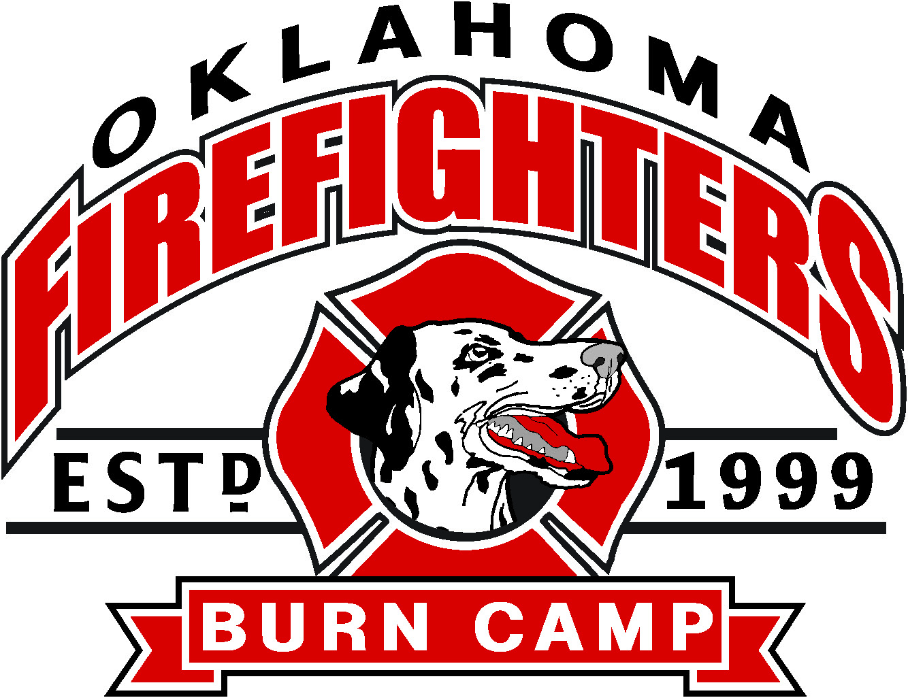 | 2022 Oklahoma Firefighters Burn Camp #23  Fishing Guides and Boating Day Volunteer Sign-in Sheet  Saturday August 6th, 2022  Lake Tenkiller
Check-in time: 6-7 am, kids will arrive at 6:30-7:00am. Fishing is from 7:30-11:00am
BE READY! Free breakfast and lunch will be provided!
Please fill out one form per boat
Name:________________________________________________________
Size and type of boat:___________________________________________
Shirt sizes: (for all that will be coming) SM MD LG XL XXL XXXL
Address:________________________________________________________
Cell Phone:_______________________
E-mail:__________________________________
Club Name (If you have one):_______________________________________
Name of additional people coming:___________________________________
Please Email the filled out form to Renee Chronister at almendarezra@gmail.com
Or fax filled out form to 918-550-6749
For questions contact Renee Chronister at 918-824-0610
Web info: okffburncamp.com

General Information
- Event begins at 6:00 and ends at 11:30am at Cherokee Landing State Park 28610 Park 20 Park Hill, OK 74451
- All volunteer boaters and fishermen are invited to have breakfast, as well as lunch with the campers, counselors, and volunteers following the fishing and boating event
- One adult camp counselor will accompany each child camper on every boat
- Life jackets will be provided and must always be worn by all campers when in the boat or near water
- Free snacks and water will be provided for the campers and counselors
- Rods, reels, and tackle will be provided to the children prior to boarding the boats
- Awards for different fish categories will be given out during lunch
- We will be launching from the boat this year so you don’t have to dock your boats on the rocks and risk scratching them up
- Fire men will be available to help back you in
If you have any questions please contact Renee Chronister at 918-824-0610

